Remote IT Support Practice (Simulation)

The goal of this project was to simulate an actual day in the life of an IT Support role by remotely connecting to a client using AnyDesk and resolving a slow computer.

1) Receiving the Ticket + Beginning the Remote Session
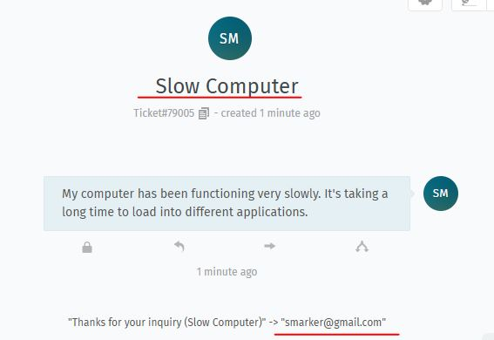

I received a ticket from a user in a different department with a concern that their computer was functioning very slowly and that they were experiencing difficulty when they were trying to open new applications due to prolonged loading times. Upon receiving their ticket, I engaged with the client and began a remote session using a remote IT support tool called AnyDesk.

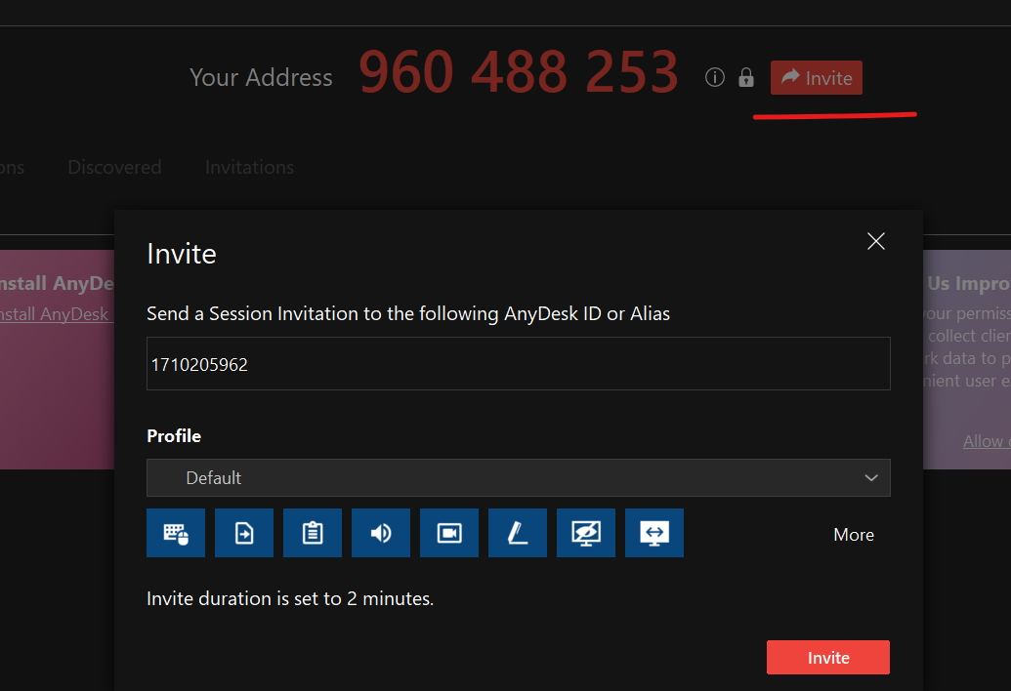

I instructed them to navigate to the “invite” button and to input my AnyDesk address, allowing me to join their session.

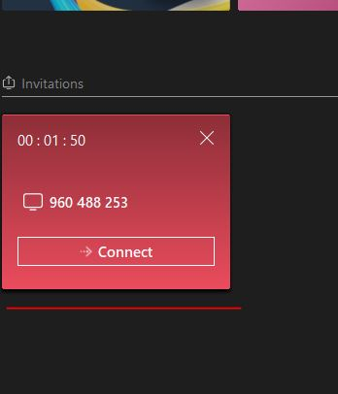

I then received the invitation to join.

2) Diagnosing the Problem
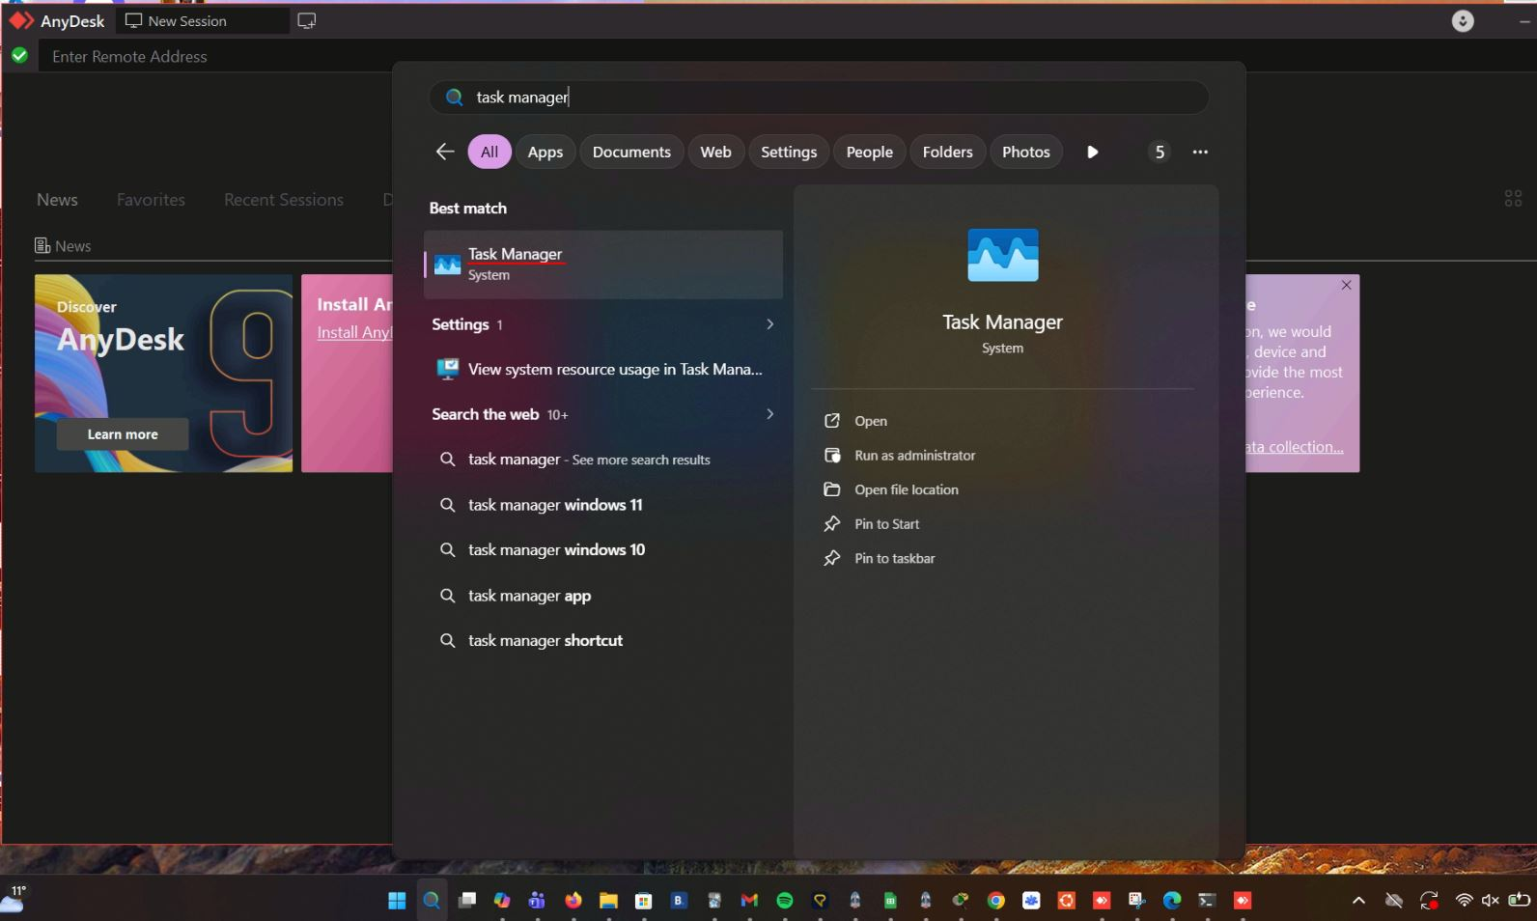

Upon gaining remote access to their device, I navigated to Task Manager to view the current performance of their machine.
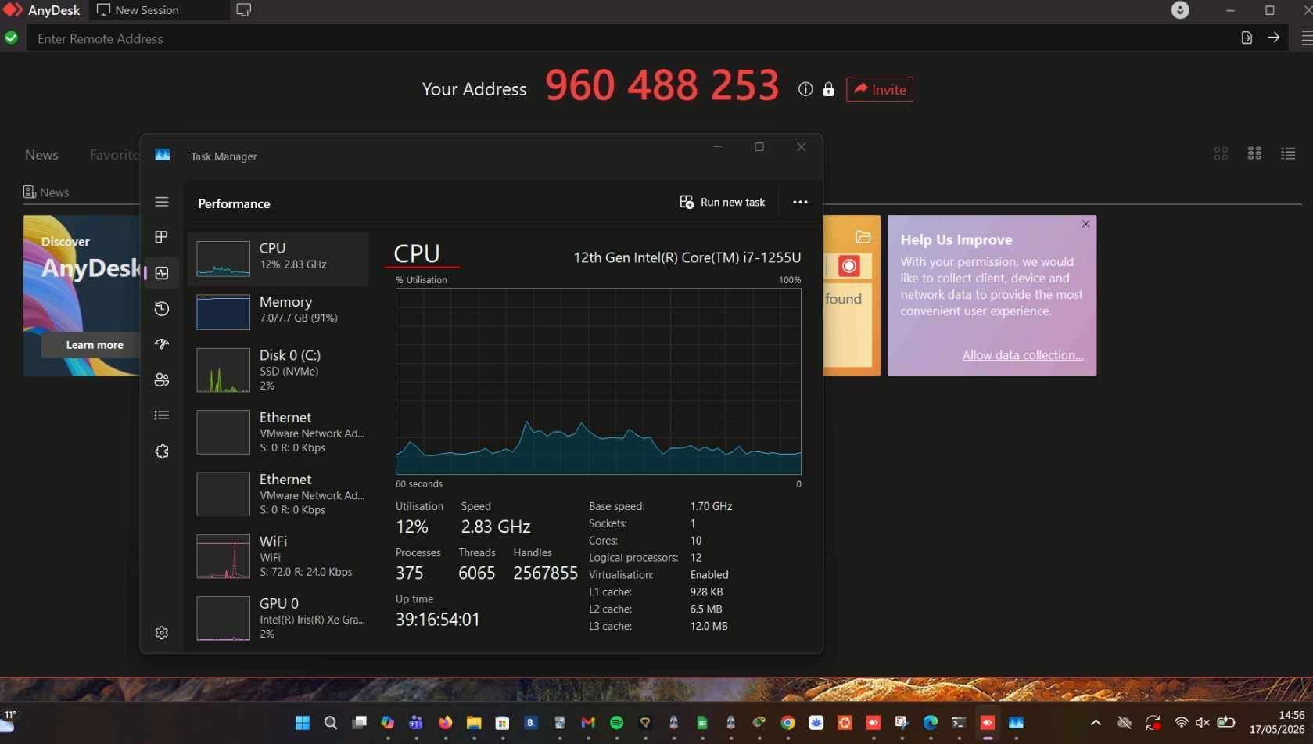

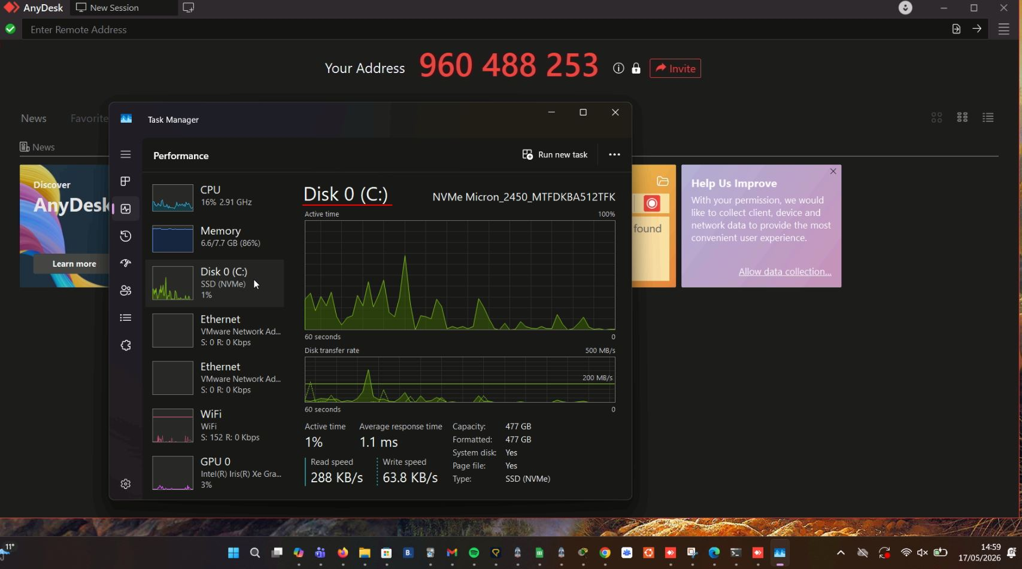
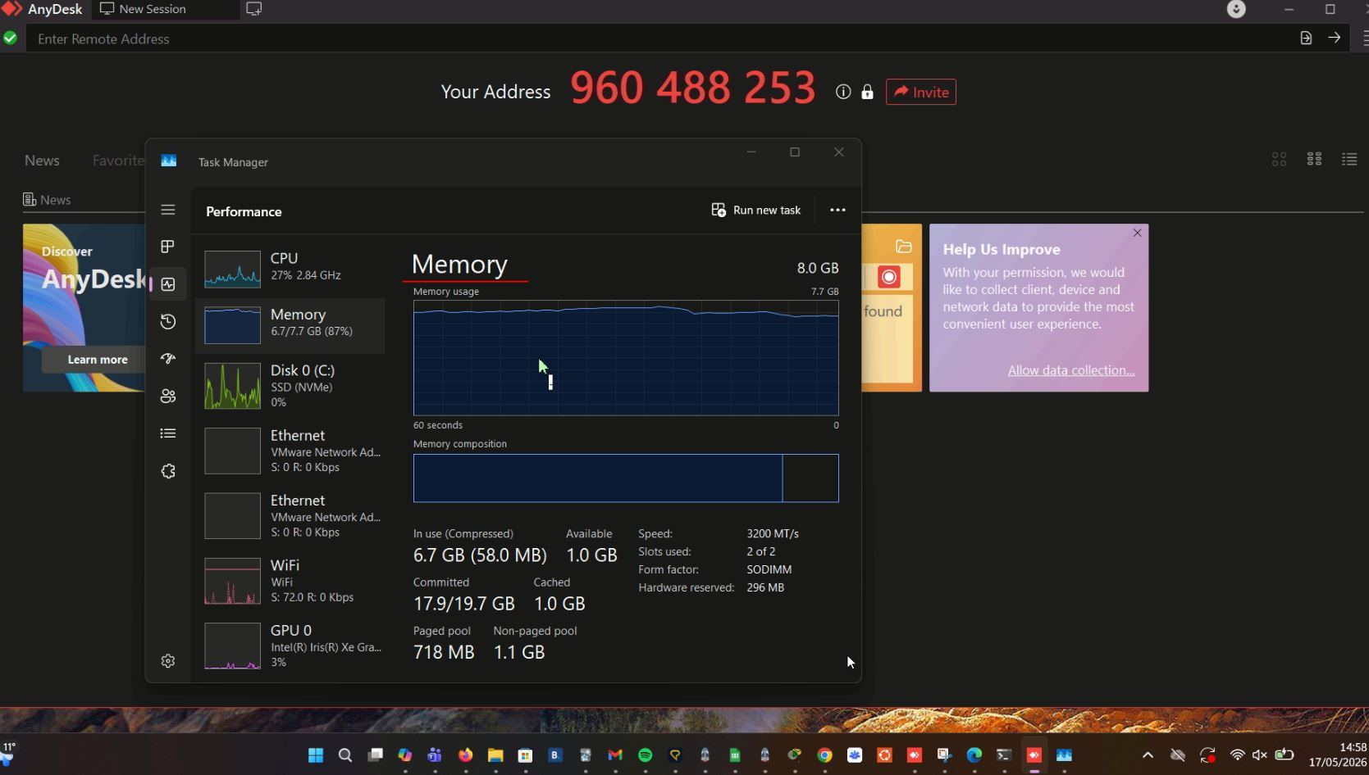
After viewing their performance statistics in task manager, I could see that their CPU, Memory and Disk usage was very high. Upon viewing these statistics, I identified that the source of the problem which was contributing to their slow performance was the total number of extra applications that they had running simultaneously.

3) Resolving the Problem
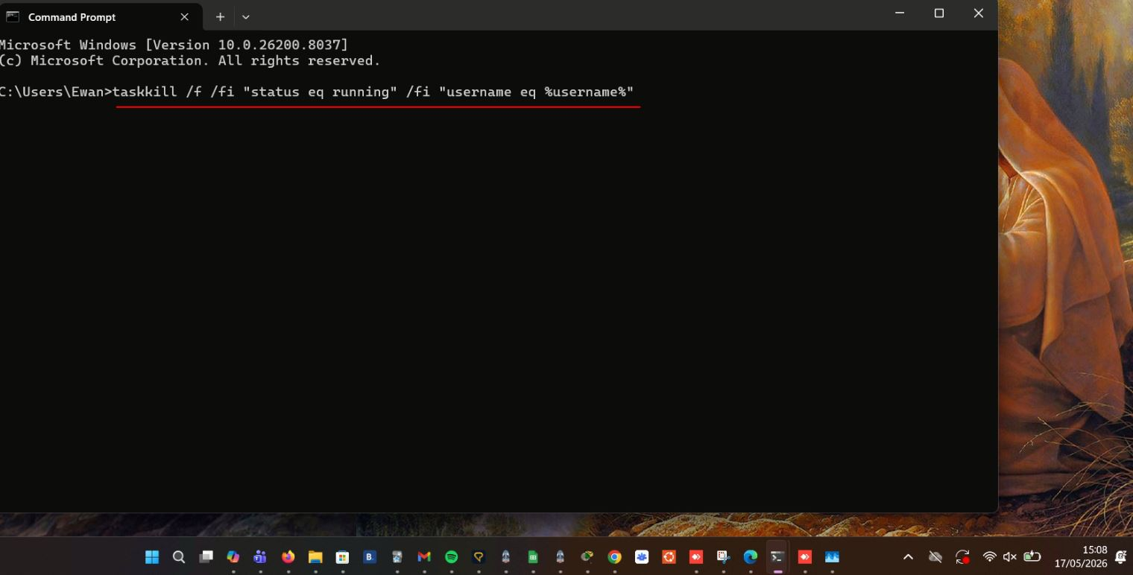
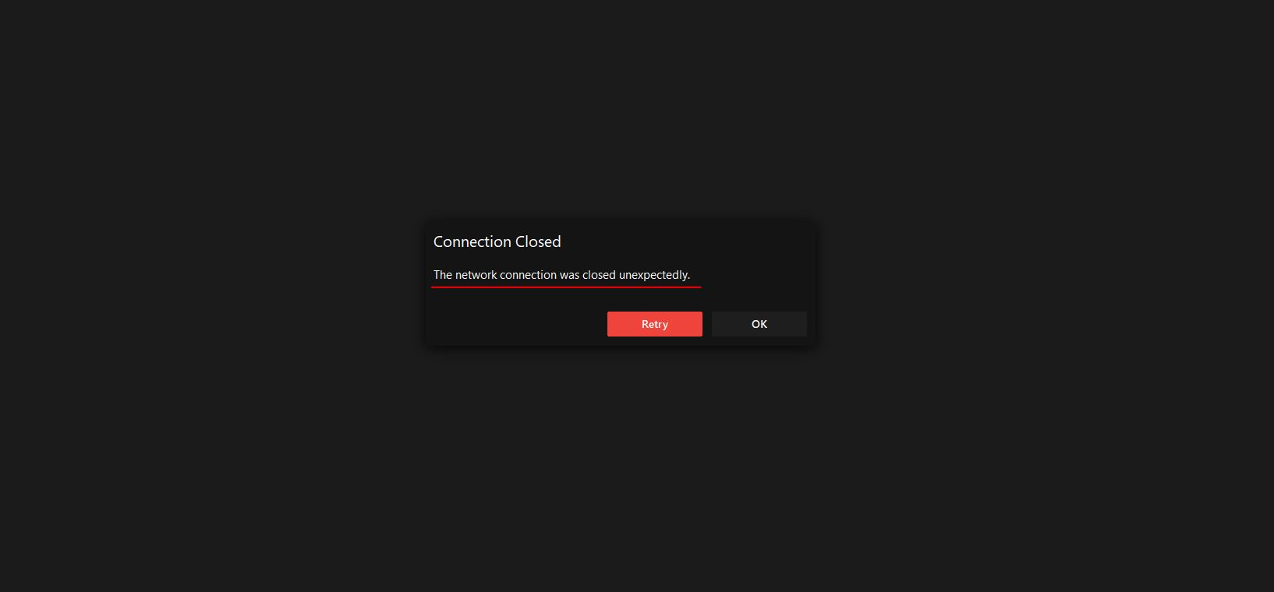
To resolve the problem, I navigated to their CMD and executed the command: taskkill /f /fi "status eq running" /fi "username eq %username%". This command force closed all of their applications including our AnyDesk session.

4) The Results

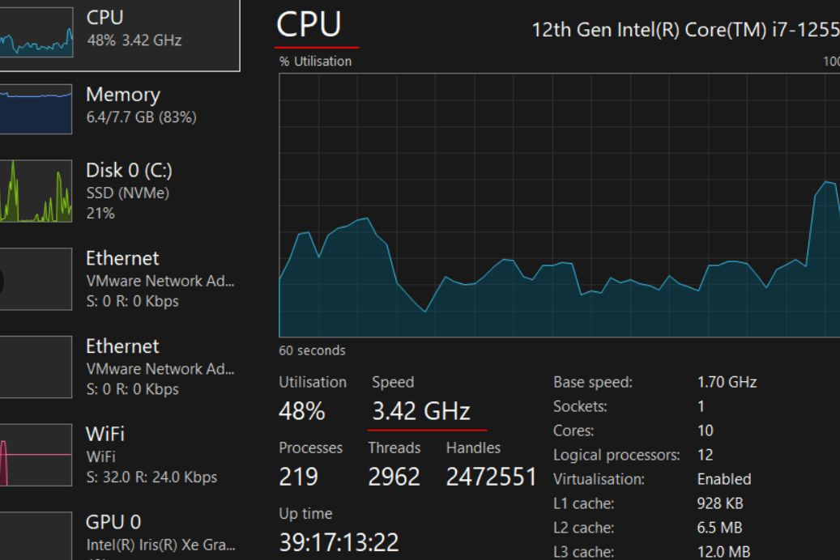
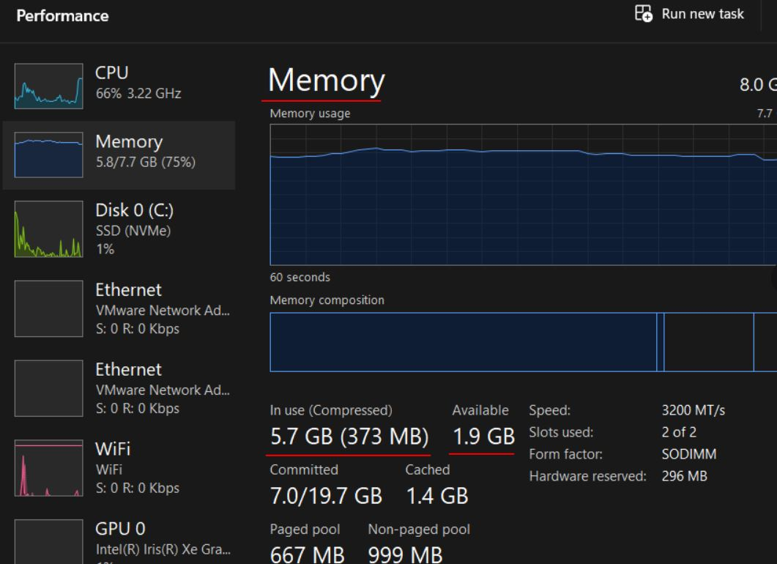

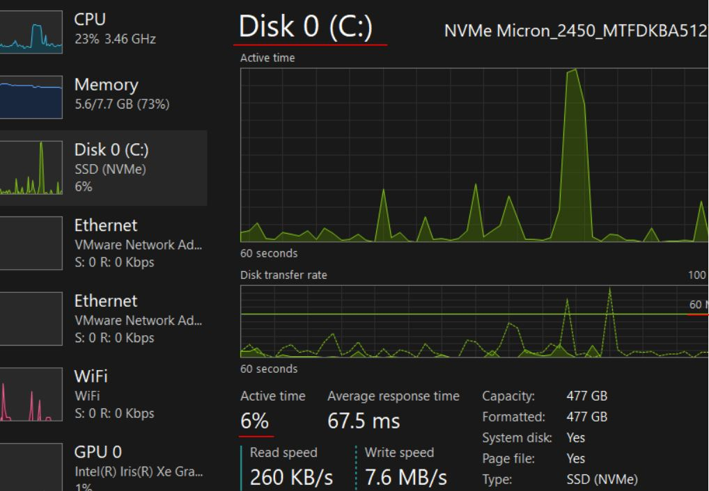
From the results we can see that by force closing all of the user’s applications, the CPU speed increased from 2.83 GHz to 3.42 GHz (+0.59 GHz). The memory usage decreased from 6.7 GB to 5.7 GB (-1.0 GB) and the Disk Active time increased from 1% to 6% due to the computer wriitng additional logs and clearing cache files upon force close (this figure is still in a low range without impacting performance).

